27th January 2026

Dear Parents

We’re Taking Part in the Wingfield Barns Local Primary School Exhibition!

We are very excited to announce that our school will be taking part in the Wingfield Barns Local Primary School Exhibition and Competition. Theme; Living in the Countryside.

This special free event brings together local primary schools to celebrate children’s creativity, imagination, and hard work. Pupils will have the opportunity to showcase their artwork in a real exhibition space, where they will be viewed by members of the local community.

There will be a Private View on Saturday 14th February from 1:00–2:00pm, and the exhibition will be open to the public from 16th–21st February, 10:00am–3:00pm.

Our children have been working enthusiastically on their entries, and we are incredibly proud of the effort, creativity, and teamwork they have shown. Taking part in this exhibition is a wonderful opportunity for pupils to build confidence, express themselves, and feel part of the wider community.

There is a competition for each year group that will be judged by a local artist and high school teacher(s) with the awards being gifted by Wingfield Barns. The Arts Society Diss has kindly donated vouchers for each school to spend on art equipment.

We wish all our pupils the very best of luck in the competition and look forward to sharing photos and updates from the event.

Yours sincerely
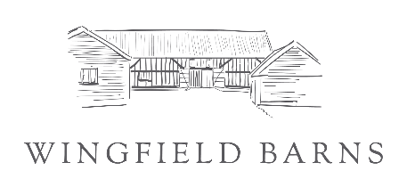

Mrs Jones
Assistant Academy Head

www.wingfieldbarns.com

