2nd February 2026

Dear Parents

Bad debt policy

Waveney Valley Primary schools follows the trusts policy in how it approaches debts within our schools. This can be found here: https://www.consortiumtrust.org/trust-policies

Did you know that if a debt is left unpaid then this has to come out of the school budget which means that money which should be spent on the children’s education is used to pay for debts.
One way to avoiding debts is checking whether you are entitled to Free School Meals, please check here: https://www.gov.uk/apply-free-school-meals. This allowance is a statutory right, and it is important that you use it if you qualify as it can also lead to additional support in other educational areas not just your child’s meals.

All payments to school should be made using the Arbor online payment system. Our schools aim to be cashless as much as possible as this reduces administrative time. A great deal of time can be spent chasing parent payments which is time that our admin team could be spending supporting staff with the educational focus of the school. All meals, nursery sessions, Breakfast and After school clubs, Residential visits and Educational visits can be paid through the online system, and payment must be made in advance at the time of booking. All club sessions must be booked in advance to ensure an accurate register for clubs is available to staff and that adequate staff are in attendance.

It has always been policy that school meals are to be paid in advance and we should not be providing any meals without payment, except those that are entitled to free school meals. If a debt has occured and is not cleared within 5 days, parents must provide a packed lunch. In a case when a debt payment is not received nor a packed lunch provided, the school will phone the parent to request immediate payment. Otherwise, they must provide a packed lunch before lunch time or arrange to take their child home for lunch.

Yours sincerely

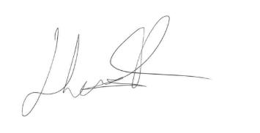
Mr Henry Huxtable
Academy Head Teacher

