Spring Planet earth |  | Vocabulary | Locational knowledge | Place knowledge  (similarities and differences) | Human and physical Geography | 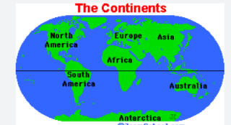  Geographical skills and fieldwork
KS1 | Could all animals live in the same place? Zzz | Continent  Ocean  Equator  Habitat  Weather pattern | Name the world’s continents and oceans.  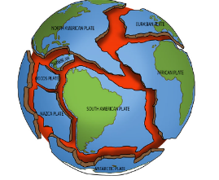  Know the location of hot and cold areas of the world in relation to the Equator and the North and South Poles. | Know the similarities and differences between 2 different localities  Explore seasonal and daily weather patterns in the United Kingdom (also covered in science) | Children discuss the habitat in hot and cold areas of the world in order to answer the lead question?  Ask and answer geographical questions (such as: What is this place like? What or who will I see in this place? What do people do in this place? What is the weather like?). | 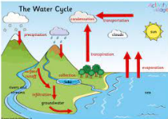  Locate the world’s continents and oceans on a world map
LKS2 | Does human activity increase the risk of natural disasters? Bscb | Natural disaster  Physical geography  Earthquake  Tsunami  Prone  Settlement  Water cycle | Identify areas across the world that are prone to natural disasters | Know how human settlement and land use in areas prone to natural disasters, are at risk    Understand the systems that are in place to support humans after natural disasters | Know the physical geography of countries/places that experience natural disasters –Earthquakes leading to Tsunamis and therefore flooding | Know the elements of the water cycle  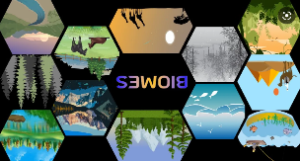
UKS2 | How do we want the future living conditions to be for each species?  (Greta Thunberg) | Species  Biome  Vegetation belt  Climate change | Know how locations around the world are changing and explain some of the reasons for change | Compare the carbon footprint of two food items | Research a range of human activities ie trade links, distribution of natural resources including energy, food and water supplies and discuss how these impact the living conditions for humans and animals | Describe the key aspects of a range of biomes and vegetation belts

Britain Summer |  | Vocabulary | Locational knowledge | Place knowledge  (similarities and differences) | Human and physical Geography | Geographical skills and fieldwork
KS1 | How is the United Kingdom like a puzzle?  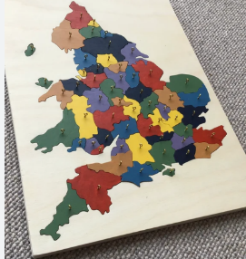 | United Kingdom (UK)  country  capital cities  surrounding  compass points | Use world maps, atlases and globes to identify the United Kingdom and its countries.  Know the four countries that make the United Kingdom.  Know the four capital cities of the United Kingdom  Know the surrounding seas near the UK.  Know the 4 main compass points and can show this on a map | Ask and answer geographical questions (such as: What is this place like? What or who will I see in this place? What do people do in this place?). | Children can identify seasonal and daily weather patterns in the UK  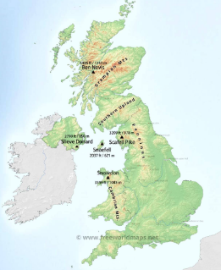 | Use a map to identify whether a location is a city, town, village, coastal or rural area.
LKS2 | Do the largest countries have the largest populations? | population density  physical geography  population size | Children know the names and locations of some of the countries of Europe  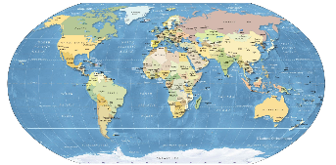 | Children can use geographical language and resources to compare the size of European countries  Children can compare the population density of some European countries | Children can graph findings to enable comparisons between human and physical characteristics  Children know why the physical geography of a country affects the population size | Use maps, atlases, globes and digital/computer mapping to locate countries and describe their features
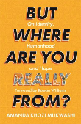  UKS2 | What’s the difference between where we live and where we originate from?  Resource link Amanda Khozi Mukwashi | migration  human migration  geographical diversity | Children understand the meaning of the term migration  How geographical diversity affects where people live. |   The names and locations of countries that humans migrate from and to. | Children can explain the reasons why humans move country  Children begin to understand the social and cultural issues faced by migrants | Children use a range of geographical resources to give detailed descriptions and opinions of the physical and human features of a location

Autumn Humankind |  | Vocabulary | Locational knowledge | Place knowledge  (similarities and differences) | 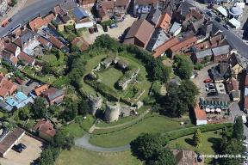  Human and physical Geography | Geographical skills and fieldwork
KS1 | How have humans changed our local area? | Grid reference  Compass  Human features  Physical features  Land use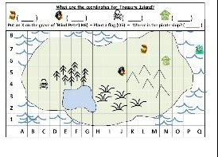 | How to use locational language (e.g. near and far) to describe the location of features and routes on a map.  Know the location of the school in relation to the coast and the nearest town or city | Ask and answer geographical questions (such as: What is this place like? What or who will I see in this place? What do people do in this place?).  Compare plans and maps to their observations of the local area | use aerial photographs to recognise landmarks and basic human and physical features in the local area | Use simple fieldwork and observational skills to study the geographic location of the school (Know what is near to the school based on local walks and observation) .  The basic symbols used in a key on a map to identify human and physical features (rivers, forests, towns, villages, farms, houses)  How to use and apply basic grid references (A1, B1) and basic compass directions (north, south, east and west)
LKS2 | How has nature changed Dunwich? | Erosion  Four figure grid references  Physical features  Eight points of a compass | How to identify the key physical features of Dunwich using symbols on a map.  How to use the eight points of a compass, four-figure grid references, to communicate knowledge of Dunwich in relation to the rest of the United Kingdom | Explain own views about Dunwich and what is happening there to answer the lead question | Ask and answer geographical questions about the physical and human characteristics of a location.  Know how some aspects of the land/coast have changed over time.(erosion) | 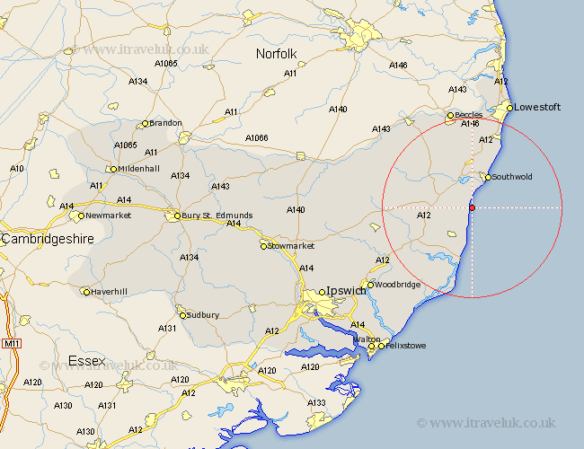  Use maps, atlases, globes and digital/computer mapping to locate Dunwich and surrounding areas
UKS2 | Do all societies impact the planet in the same way? | The Equator  Northern & Southern Hemisphere  Tropics of Cancer & Capricorn  Arctic and Antarctic Circle  Longitude & Latitude  Time zones (including day and night) | Know how countries and geographical regions are interconnected and interdependent. | Compare and debate the geographical diversity of England with a contrasting country in a different Hemisphere | Know how choices made by humans in diverse populations impact climate, pollution and the environment | Use atlases, tables and graphs understand time zones and temperature differences in the tropics

Summer Civilisations |  | Vocabulary | Locational knowledge | Place knowledge  (similarities and differences) | Human and physical Geography | 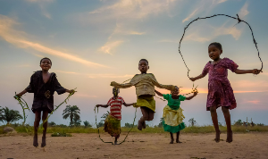  Geographical skills and fieldwork
KS1 | How is life different for children across the world? | Similarities & differences  United Kingdom  contrasting  non- European country  city, town, village, coastal, rural  physical geography  human geography | Know the geographical similarities and differences of a small area of the United Kingdom and of a contrasting (non-European) country  Know how to use the key features of a location to say whether it is a city, town, village,, coastal or rural area. | Ask and answer geographical questions (such as: What is this place like? What or who will I see in this place? What do people do in this place? How do children live in this place?). | Know the geographical similarities and differences of a small area of the United Kingdom and of a contrasting (non-European) country  Know how physical and human geography affects the opportunities and lives of children in contrasting places | Use world maps, atlases and globes to identify the United Kingdom and its countries  Use maps to identify a contrasting non- European country
LKS2 | Where does a river start and end? | mouth  source  meander  delta  tributary  northings  eastings | 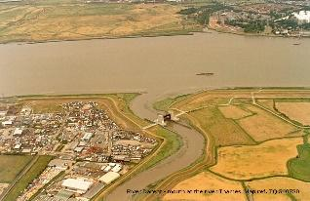  Identify the start and end of a local river using maps and where possible local visits | Describe the journey of a river comparing its size and use in different local places | Know and describe the physical features of rivers.  Ask and answer geographical questions about the physical and human characteristics of a location | Know how to use the eight points of a compass and four-figure grid references, to communicate  knowledge of rivers and seas  Use fieldwork sketches maps and digital technologies to observe and locate local rivers
UKS2 | How have cartographers represented London over time? | aerial images  topological maps - as in London’s Tube map and Ordinance Survey maps).  human features  physical features  human activity | 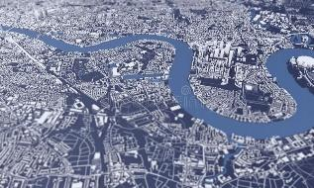  Use a range of geographical resources to give detailed descriptions of features of a location | Know how physical features affect human activity within a location (London) over time.  Know and compare the key features and uses of a range of maps such as aerial images, topological maps - as in London’s Tube map and Ordinance Survey maps). | 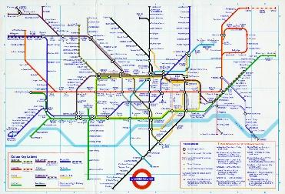  Know how the physical and human features of London have changed over time – using maps to explain their understanding | Collect and analyse statistics and other information in order to draw clear conclusions about how a location has changed  Analyse and give views on the effectiveness of different geographical representations of a location

